Backend Development & Configuration
This phase focuses on developing the core backend structure and business logic of the Auto Ticket Classification system in ServiceNow. It includes creating and configuring tables and fields to store support tickets, user details, issue types, categories, subcategories, priority, and ticket status.
Server-side scripts, Business Rules, and automation are developed to analyze incoming support requests and automatically identify the appropriate issue type, category, and subcategory. Based on the classification, the system can also assign the appropriate priority and route the ticket to the relevant IT support team.
For example:
User Request: “My laptop cannot connect to the school Wi-Fi.”
The backend processes the request and automatically determines:
- Issue Type: Network Connectivity
- Category: Network
- Subcategory: Wi-Fi
- Priority: Medium
- Assignment Group: Network Support
The system then creates/updates the ticket and can automatically notify the student or teacher with the ticket number.

In simple terms
Input → Classification → Ticket Creation → Assignment → Notification
This phase is therefore responsible for making the automatic classification logic actually work behind the ServiceNow application, rather than just designing the idea or user interface.
Three activities included in this process are listed below:
Activity 1: Creation of Custom Table to Store Ticket Records
Activity 2: Field Creation and Data Type Configuration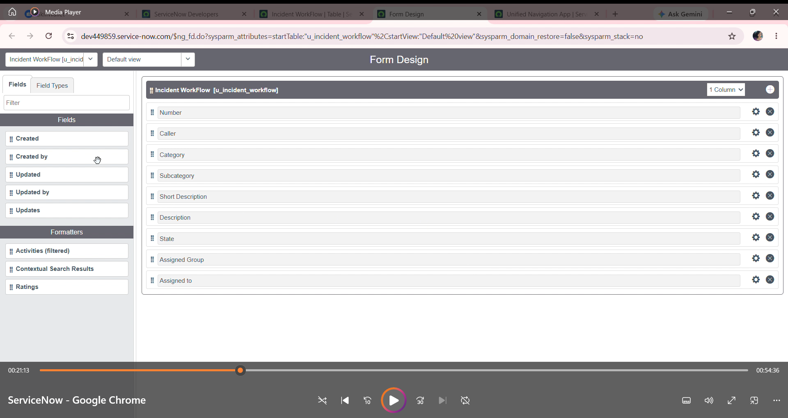
Activity 3: Implementing Dependency Between Category and Subcategory Choice Fields

